EXPT NO: 1 | BUILDING AND TRAINING A SIMPLE ARTIFICIAL NEURAL NETWORK (ANN) FOR REGRESSION AND CLASSIFICATION
DATE: 24.7.2026

PRE-LAB QUESTIONS (PROVIDE BRIEF ANSWERS TO THE FOLLOWING QUESTIONS)

PRE-LAB ANSWERS
1. What is an ANN?
An Artificial Neural Network is a computational model inspired by the human brain, made of interconnected neurons in layers. Each neuron applies weights, a bias, and an activation function to its inputs. It learns patterns by adjusting weights during training. Used for regression, classification, and pattern recognition.

2. Functions of input, hidden, output layers?
The input layer takes in the raw feature values without computation. Hidden layers process data through weights, biases, and activation functions to learn patterns. The output layer gives the final prediction. Regression outputs a number; classification outputs class probabilities.

3. Why is feature scaling important?
Feature scaling brings all input values to a similar range. Without it, larger-range features dominate weight updates, slowing convergence. Scaling helps the optimizer converge faster and more reliably. It improves model accuracy and training stability.

4. Regression vs classification with examples?
Regression predicts continuous values, like house price prediction. Classification predicts discrete class labels, like malignant vs benign. The output type differs: numeric vs categorical. This leads to different loss functions and evaluation metrics.

5. Role of activation function?
It introduces non-linearity so the network can learn complex patterns. Without it, the ANN behaves like a linear model. ReLU is common in hidden layers. Sigmoid/Softmax are used in output layers for classification.
AIM
To understand the implementation of Artificial Neural Networks (ANN) using TensorFlow and evaluate their performance on regression and classification problems.

SOFTWARE REQUIREMENTS
- Python 3.x
- Google Colab / Jupyter Notebook
- TensorFlow 2.x
- NumPy
- Pandas
- Matplotlib
- Scikit-learn

LEARNING OBJECTIVES
After completing this experiment, students will be able to:
- Understand the architecture of an Artificial Neural Network.
- Build an ANN for regression problems.
- Build an ANN for classification problems.
- Train and evaluate neural network models.
- Compare different evaluation metrics used for regression and classification.

THEORY
An Artificial Neural Network (ANN) is a machine learning model inspired by the human brain. It consists of interconnected neurons organized into layers.
A simple ANN contains:
- Input Layer
- Hidden Layer(s)
- Output Layer
During training, the ANN learns by updating weights using Backpropagation and an optimization algorithm such as Adam Optimizer.

PART A – ANN FOR REGRESSION
DATASET: California Housing Dataset
SOURCE: Scikit-learn
DESCRIPTION
- Samples: 20,640
- Features: 8
- Target: Median House Value

FEATURES
Feature | Description
MedInc | Median Income
HouseAge | House Age
AveRooms | Average Rooms
AveBedrms | Average Bedrooms
Population | Population
AveOccup | Average Occupancy
Latitude | Latitude
Longitude | Longitude

ALGORITHM
- Import libraries.
- Load California Housing dataset.
- Split into training and testing sets.
- Standardize the features.
- Build ANN model.
- Compile the model.
- Train the model.
- Predict house prices.
- Evaluate using:
  - MSE
  - MAE
  - RMSE
Dataset link : https://www.kaggle.com/datasets/abhinavmangalore/breast-cancer-dataset-wisconsin-diagnostic-uci

CODE:

# Name: RITHESH P Roll No: 24BAD098

# 1. Import libraries
import numpy as np
import pandas as pd
import matplotlib.pyplot as plt
import seaborn as sns
from sklearn.model_selection import train_test_split
from sklearn.preprocessing import StandardScaler, LabelEncoder
from sklearn.metrics import (accuracy_score, precision_score, recall_score,
f1_score, confusion_matrix, classification_report)
import tensorflow as tf
from tensorflow import keras
from tensorflow.keras import layers

# 2. Load Breast Cancer dataset from CSV
df = pd.read_csv('breast-cancer-wisconsin-data.csv')
print(df.shape)
print(df.head())

# Drop the 'id' column (not a feature) and any empty unnamed columns
df = df.drop(columns=['id'])
df = df.loc[:, ~df.columns.str.contains('^Unnamed')]

# Encode target: diagnosis M (Malignant) = 1, B (Benign) = 0
le = LabelEncoder()
df['diagnosis'] = le.fit_transform(df['diagnosis']) # M->1, B->0
print("Classes:", dict(zip(le.classes_, le.transform(le.classes_))))

X = df.drop(columns=['diagnosis']).values
y = df['diagnosis'].values
print("X shape:", X.shape, "y shape:", y.shape)

# 3. Split dataset
X_train, X_test, y_train, y_test = train_test_split(
X, y, test_size=0.2, random_state=42, stratify=y
)

# 4. Standardize features
scaler = StandardScaler()
X_train = scaler.fit_transform(X_train)
X_test = scaler.transform(X_test)

# 5. Design ANN
model = keras.Sequential([
layers.Dense(32, activation='relu', input_shape=(X_train.shape[1],)),
layers.Dense(16, activation='relu'),
layers.Dense(8, activation='relu'),
layers.Dense(1, activation='sigmoid') # Sigmoid for binary classification
])

model.summary()

# 6. Compile model
model.compile(optimizer='adam', loss='binary_crossentropy', metrics=['accuracy'])

# 7. Train model
history = model.fit(
X_train, y_train,
validation_split=0.2,
epochs=50,
batch_size=16,
verbose=1
)

# 8. Predict labels
y_pred_prob = model.predict(X_test).flatten()
y_pred = (y_pred_prob >= 0.5).astype(int)

# 9. Evaluate: Accuracy, Precision, Recall, F1-score, Confusion Matrix
accuracy = accuracy_score(y_test, y_pred)
precision = precision_score(y_test, y_pred)
recall = recall_score(y_test, y_pred)
f1 = f1_score(y_test, y_pred)
cm = confusion_matrix(y_test, y_pred)

print(f"Accuracy : {accuracy:.4f}")
print(f"Precision : {precision:.4f}")
print(f"Recall : {recall:.4f}")
print(f"F1-score : {f1:.4f}")
print("Confusion Matrix:\n", cm)
print("\nClassification Report:\n", classification_report(y_test, y_pred, target_names=le.classes_))

# Plot training accuracy curve
plt.plot(history.history['accuracy'], label='Training Accuracy')
plt.plot(history.history['val_accuracy'], label='Validation Accuracy')
plt.xlabel('Epoch')
plt.ylabel('Accuracy')
plt.title('Training vs Validation Accuracy - Classification')
plt.legend()
plt.show()

# Plot confusion matrix heatmap
sns.heatmap(cm, annot=True, fmt='d', cmap='Blues',
xticklabels=le.classes_, yticklabels=le.classes_)
plt.xlabel('Predicted')
plt.ylabel('Actual')
plt.title('Confusion Matrix')
plt.show()

SCREENSHOT OF CODE
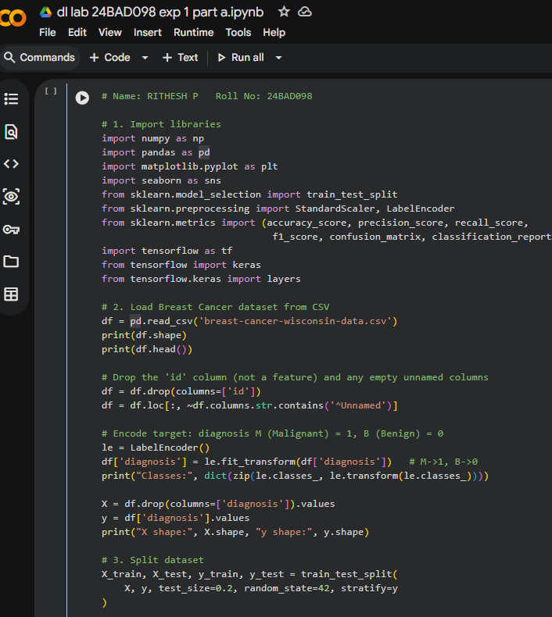
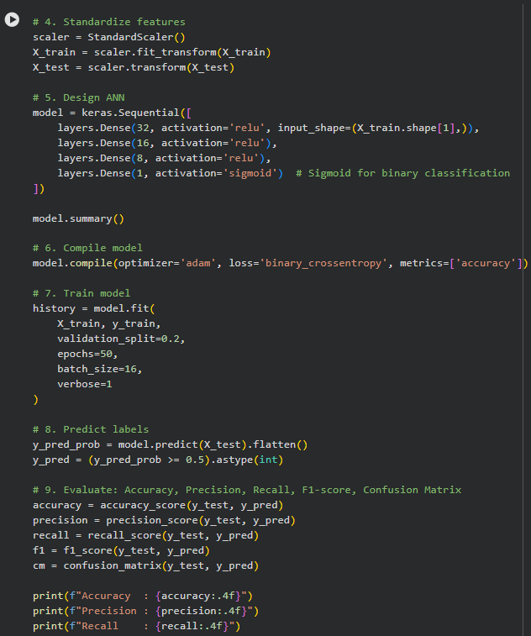
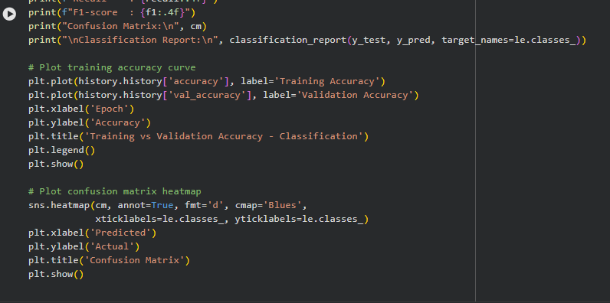

SCREENSHOT OF OUTPUT)
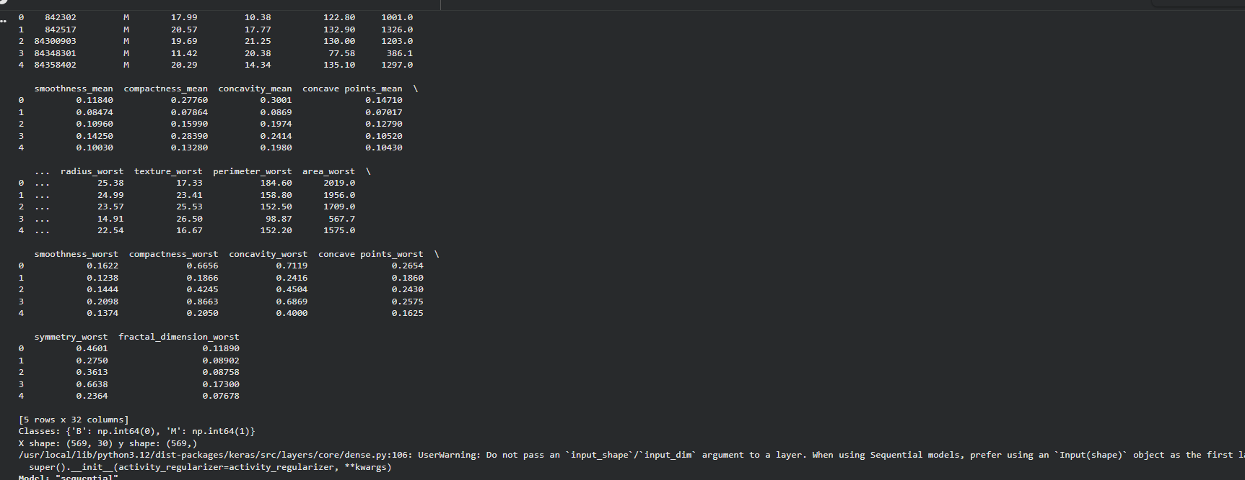
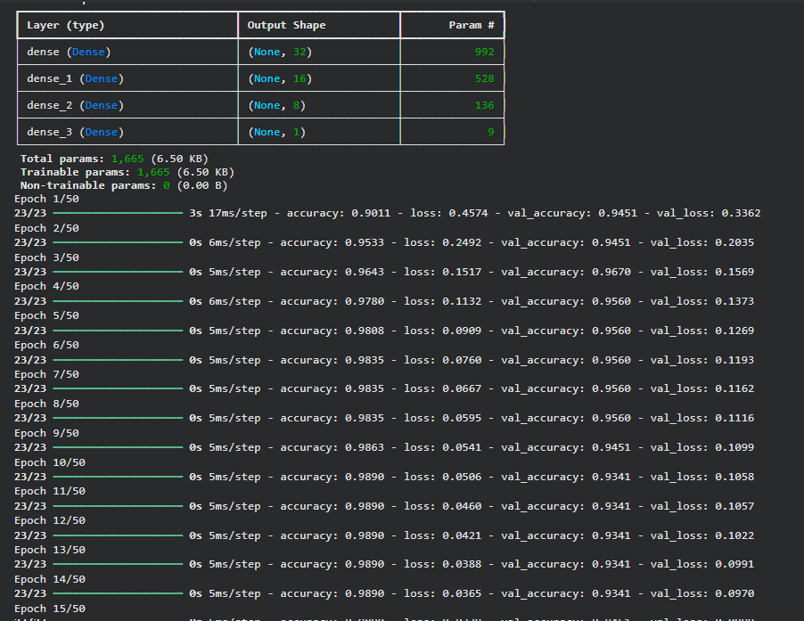
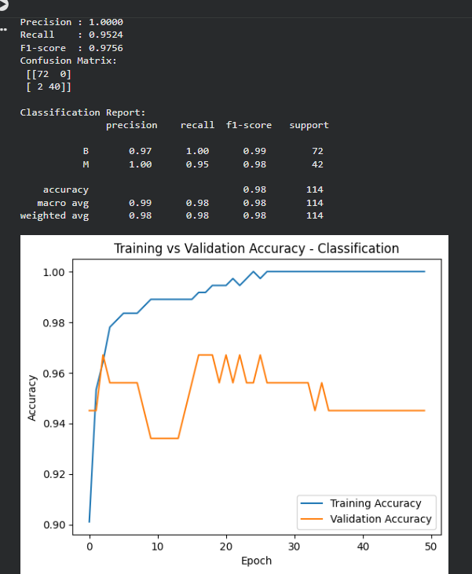
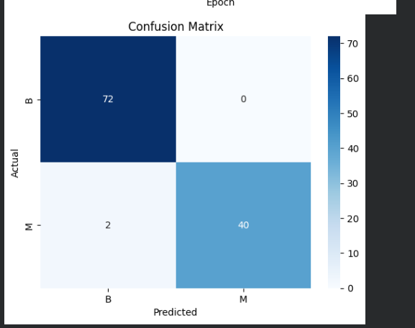

PART B – ANN FOR CLASSIFICATION
DATASET: Breast Cancer Wisconsin Dataset
SOURCE: Scikit-learn
DESCRIPTION
- Samples: 569
- Features: 30
- Classes:
  - Malignant
  - Benign

ALGORITHM
- Import libraries.
- Load Breast Cancer dataset.
- Split dataset.
- Standardize features.
- Design ANN.
- Compile model.
- Train model.
- Predict labels.
- Evaluate:
  - Accuracy
  - Precision
  - Recall
  - F1-score
  - Confusion Matrix

CODE:
# Name: RITHESH P Roll No: 24BAD098

# 1. Import libraries
import numpy as np
import pandas as pd
import matplotlib.pyplot as plt
import seaborn as sns
from sklearn.model_selection import train_test_split
from sklearn.preprocessing import StandardScaler, LabelEncoder
from sklearn.metrics import (accuracy_score, precision_score, recall_score,
f1_score, confusion_matrix, classification_report)
import tensorflow as tf
from tensorflow import keras
from tensorflow.keras import layers

# 2. Load Breast Cancer dataset from CSV
df = pd.read_csv('breast-cancer-wisconsin-data.csv')
print(df.shape)
print(df.head())

# Drop the 'id' column (not a feature) and any empty unnamed columns
df = df.drop(columns=['id'])
df = df.loc[:, ~df.columns.str.contains('^Unnamed')]

# Encode target: diagnosis M (Malignant) = 1, B (Benign) = 0
le = LabelEncoder()
df['diagnosis'] = le.fit_transform(df['diagnosis']) # M->1, B->0
print("Classes:", dict(zip(le.classes_, le.transform(le.classes_))))

X = df.drop(columns=['diagnosis']).values
y = df['diagnosis'].values
print("X shape:", X.shape, "y shape:", y.shape)

# 3. Split dataset
X_train, X_test, y_train, y_test = train_test_split(
X, y, test_size=0.2, random_state=42, stratify=y
)

# 4. Standardize features
scaler = StandardScaler()
X_train = scaler.fit_transform(X_train)
X_test = scaler.transform(X_test)

# 5. Design ANN
model = keras.Sequential([
layers.Dense(32, activation='relu', input_shape=(X_train.shape[1],)),
layers.Dense(16, activation='relu'),
layers.Dense(8, activation='relu'),
layers.Dense(1, activation='sigmoid') # Sigmoid for binary classification
])

model.summary()

# 6. Compile model
model.compile(optimizer='adam', loss='binary_crossentropy', metrics=['accuracy'])

# 7. Train model
history = model.fit(
X_train, y_train,
validation_split=0.2,
epochs=50,
batch_size=16,
verbose=1
)

# 8. Predict labels
y_pred_prob = model.predict(X_test).flatten()
y_pred = (y_pred_prob >= 0.5).astype(int)

# 9. Evaluate: Accuracy, Precision, Recall, F1-score, Confusion Matrix
accuracy = accuracy_score(y_test, y_pred)
precision = precision_score(y_test, y_pred)
recall = recall_score(y_test, y_pred)
f1 = f1_score(y_test, y_pred)
cm = confusion_matrix(y_test, y_pred)

print(f"Accuracy : {accuracy:.4f}")
print(f"Precision : {precision:.4f}")
print(f"Recall : {recall:.4f}")
print(f"F1-score : {f1:.4f}")
print("Confusion Matrix:\n", cm)
print("\nClassification Report:\n", classification_report(y_test, y_pred, target_names=le.classes_))

# Plot training accuracy curve
plt.plot(history.history['accuracy'], label='Training Accuracy')
plt.plot(history.history['val_accuracy'], label='Validation Accuracy')
plt.xlabel('Epoch')
plt.ylabel('Accuracy')
plt.title('Training vs Validation Accuracy - Classification')
plt.legend()
plt.show()

# Plot confusion matrix heatmap
sns.heatmap(cm, annot=True, fmt='d', cmap='Blues',
xticklabels=le.classes_, yticklabels=le.classes_)
plt.xlabel('Predicted')
plt.ylabel('Actual')
plt.title('Confusion Matrix')
plt.show()

SCREENSHOT OF CODE
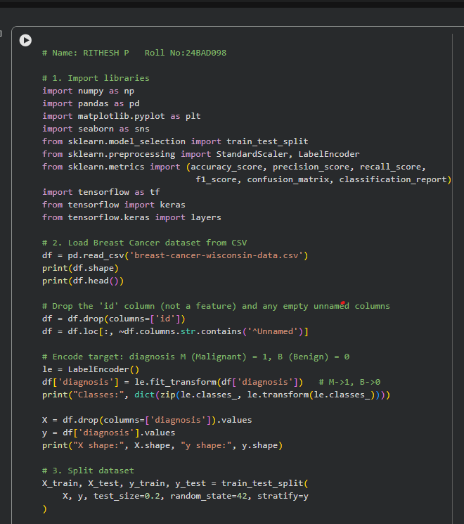
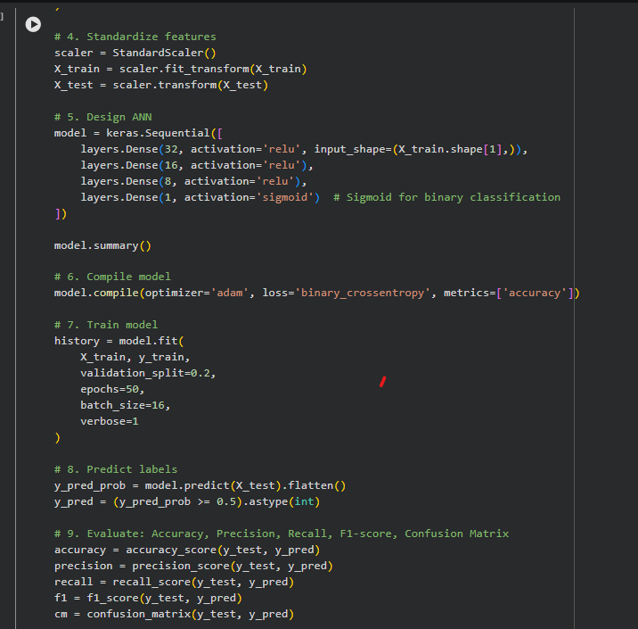
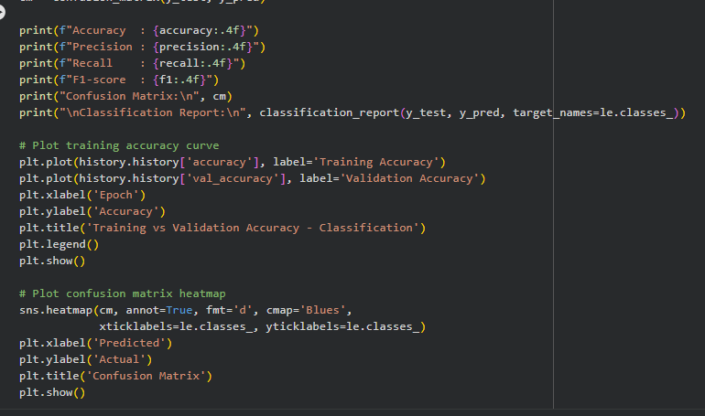

SCREENSHOT OF OUTPUT
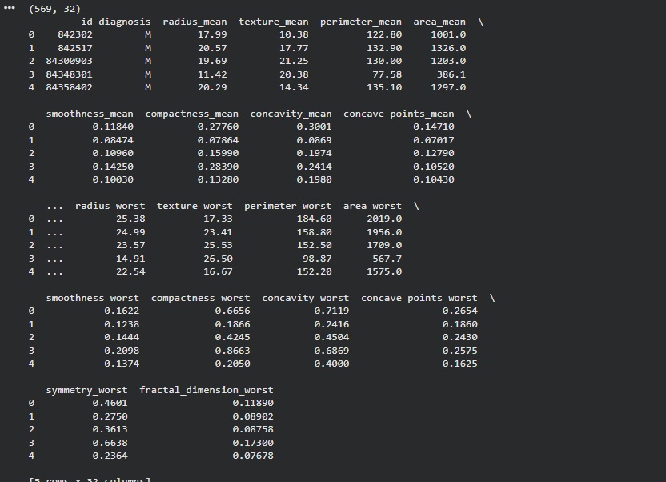
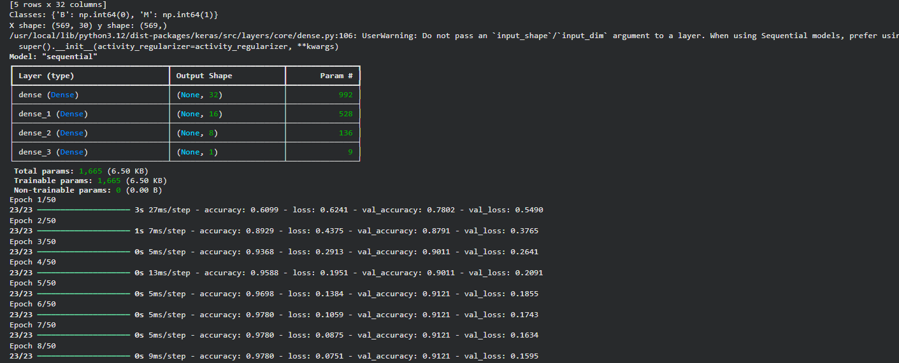
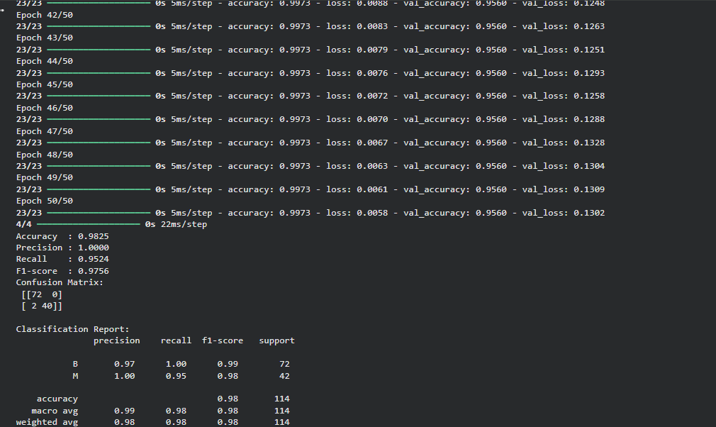
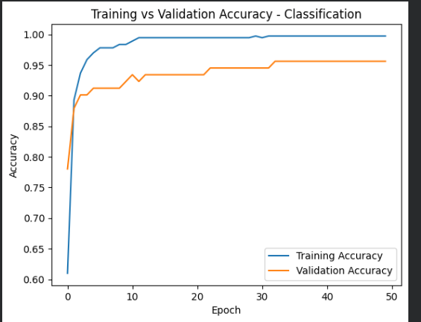
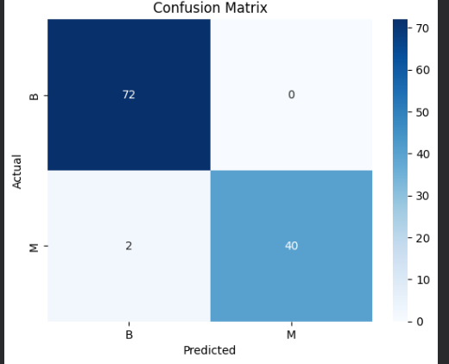

POST-LAB QUESTIONS (PROVIDE BRIEF ANSWERS TO THE FOLLOWING QUESTIONS)

1. Why is the Adam optimizer commonly used in ANN training?
Adam combines the benefits of Momentum and RMSProp. It adapts the learning rate for each parameter using estimates of the gradient's mean and variance. This gives faster, more stable convergence. It also needs minimal hyperparameter tuning, making it a strong default choice.

2. Compare MSE and MAE. Which metric is more sensitive to outliers?
MSE squares the errors, so it penalizes large errors much more heavily than small ones. MAE simply averages the absolute errors, treating all errors proportionally. This makes MSE more sensitive to outliers. MAE is more robust and gives a more even-handed measure when outliers are present.

3. Why is the sigmoid activation function used in binary classification?
Sigmoid maps any real-valued input to a value between 0 and 1. This output can be directly interpreted as the probability of belonging to the positive class. A threshold, typically 0.5, is then used to assign the final class label. This makes sigmoid well suited to binary classification output layers.

4. How does increasing the number of hidden layers affect ANN performance?
More hidden layers increase the network's capacity to learn complex, non-linear patterns. This can improve performance on difficult tasks with rich underlying structure. However, too many layers can lead to overfitting, vanishing gradients, and longer training times. The right depth depends on the complexity of the problem and the amount of available data.

5. Compare regression and classification evaluation metrics. Why are different metrics needed?
Regression tasks use metrics like MSE, MAE, and RMSE to measure the numerical distance between predicted and actual values. Classification tasks use accuracy, precision, recall, F1-score, and the confusion matrix to measure how correctly class labels are assigned. Different metrics are required because regression errors are continuous distances, while classification performance depends on correctly identifying class membership, including false positives, false negatives, and class imbalance.

ASSESSMENT
Description | Max Marks | Marks Awarded
Pre Lab Exercise | 5
In Lab Exercise | 10
Post Lab Exercise | 5
Viva | 10
Total | 30
Faculty Signature

